**Data Analyst in Power BI Data-Camp 2025**

**Section 1: Introduction to Power BI**

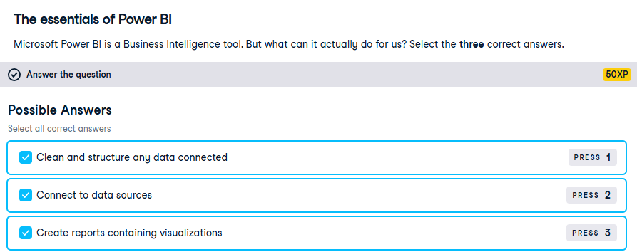

**Getting started with POWER BI**

**Exercise 1.2**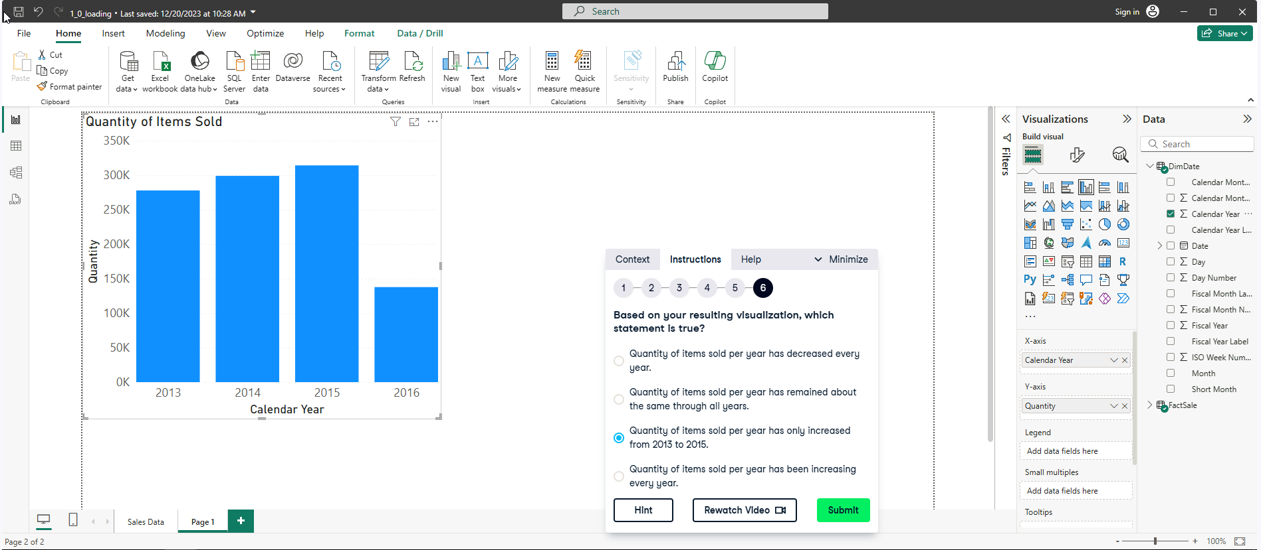

**Exercise 1.3**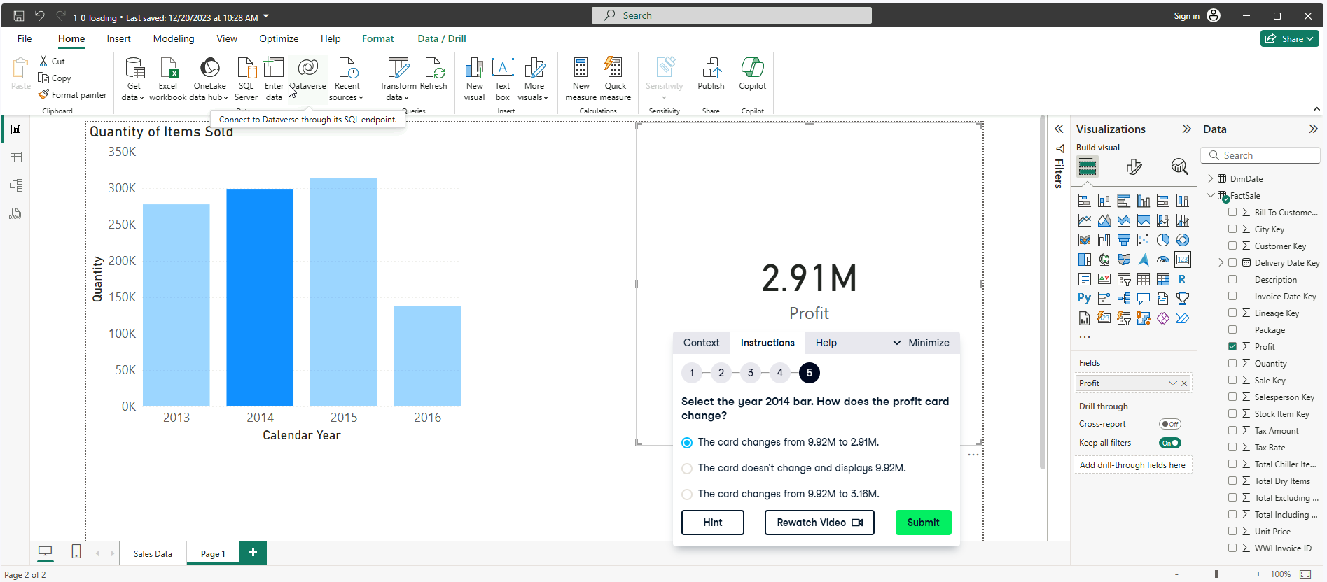

**Exercise 1.4**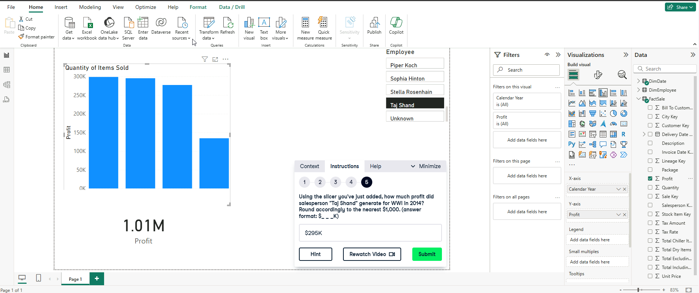

**Exercise 1.5**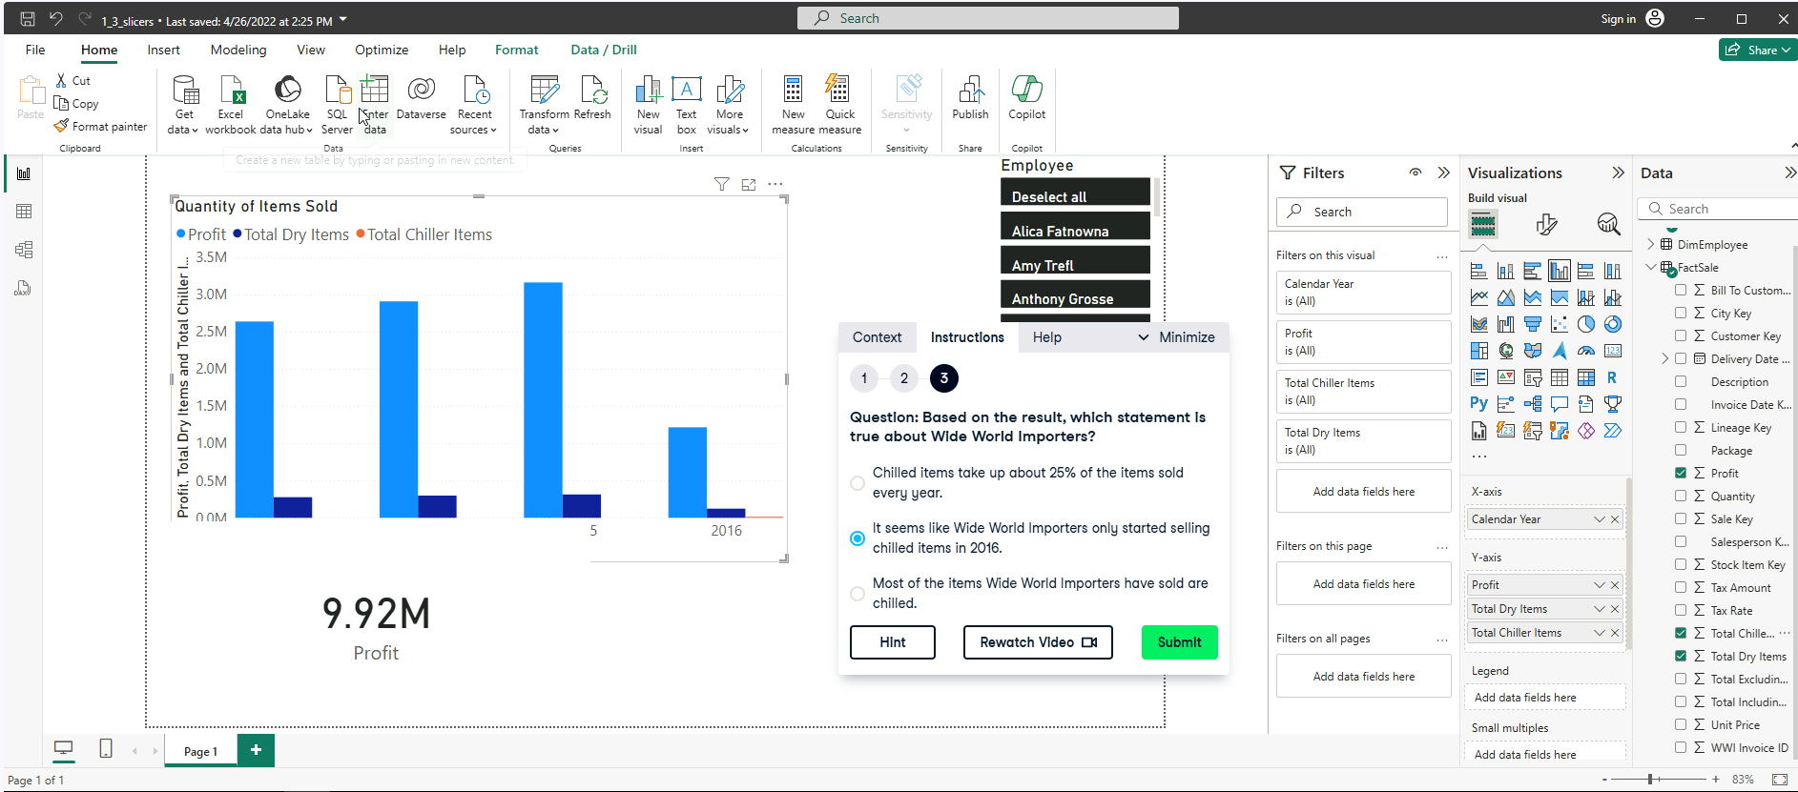

**Exercise 1.6**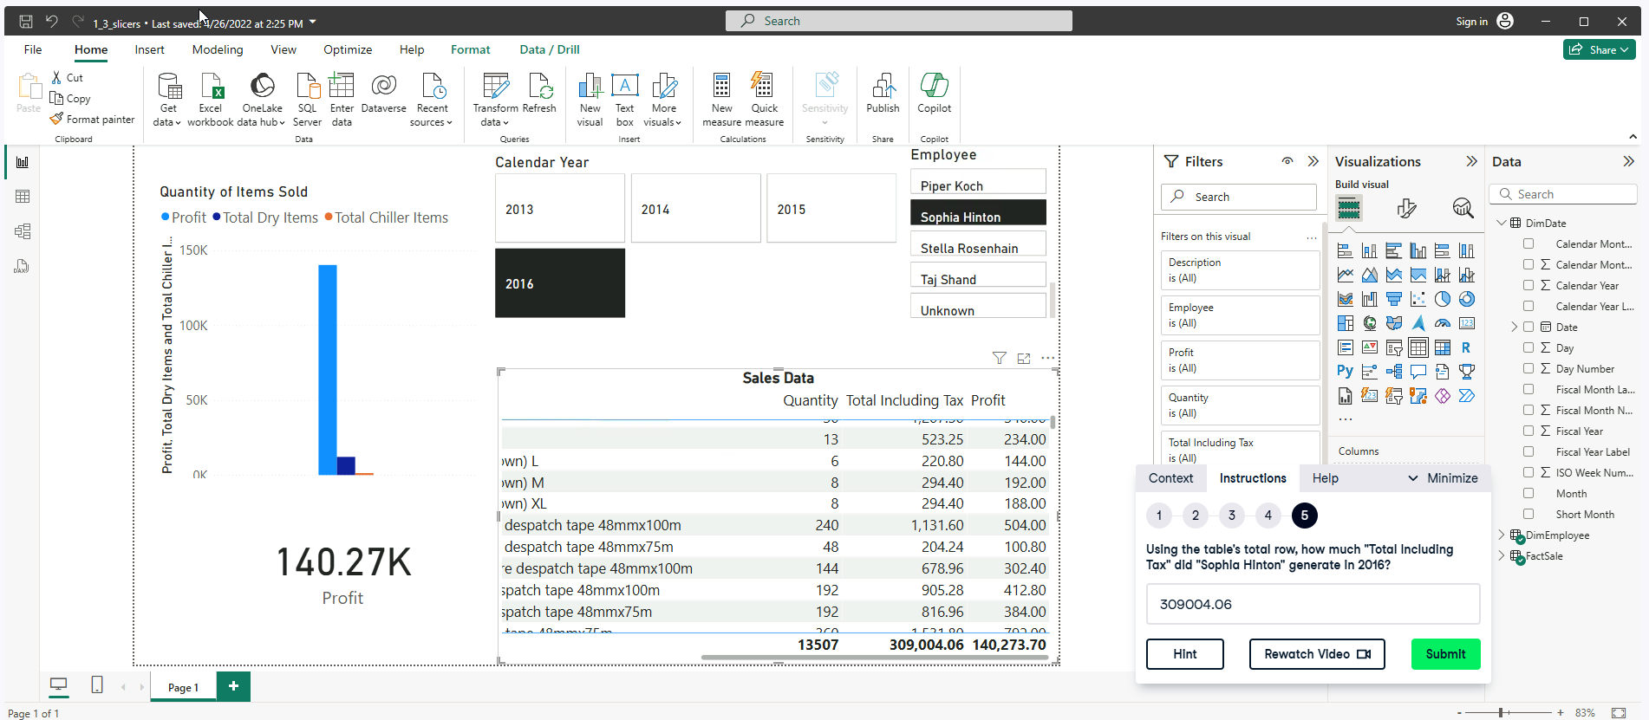

**Transforming Data**

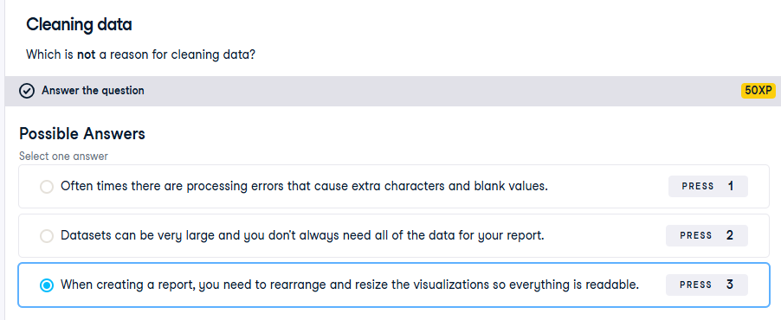

**Exercise 2.1**

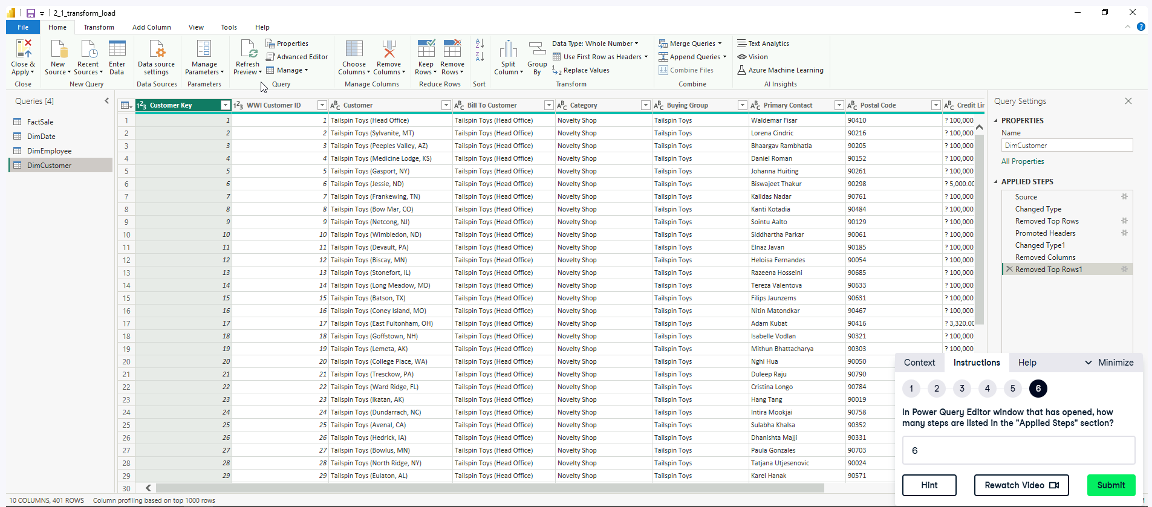

Exclude Source (does not count)

**Exercise 2.2**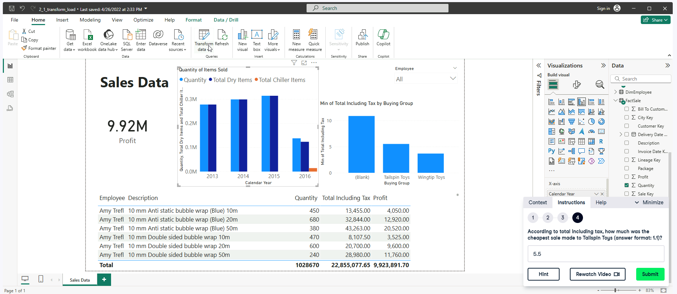

**Exercise 2.4**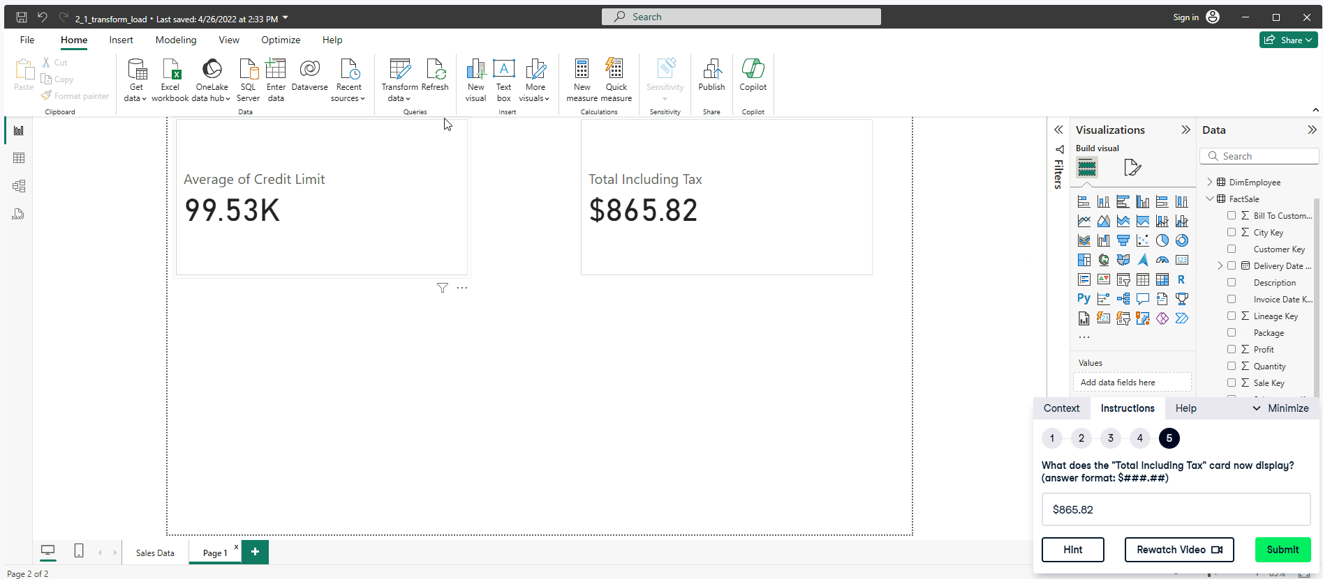

**Exercise 2.5**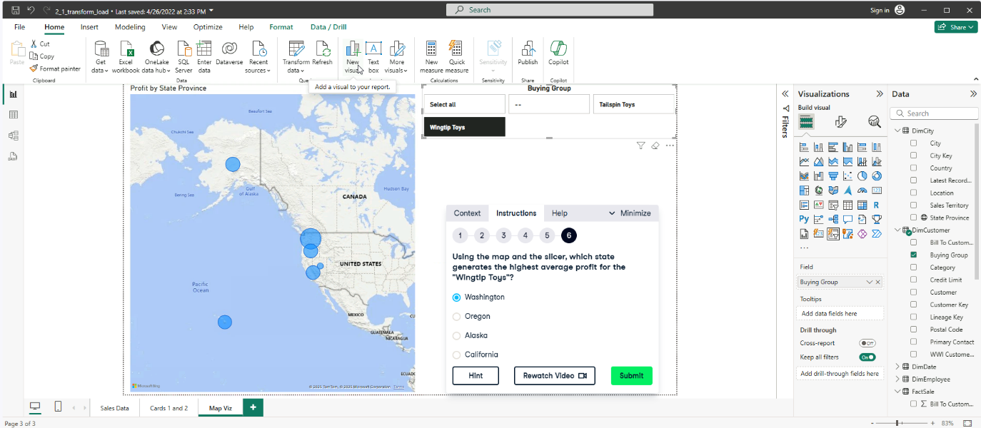

**Visualizing Data**

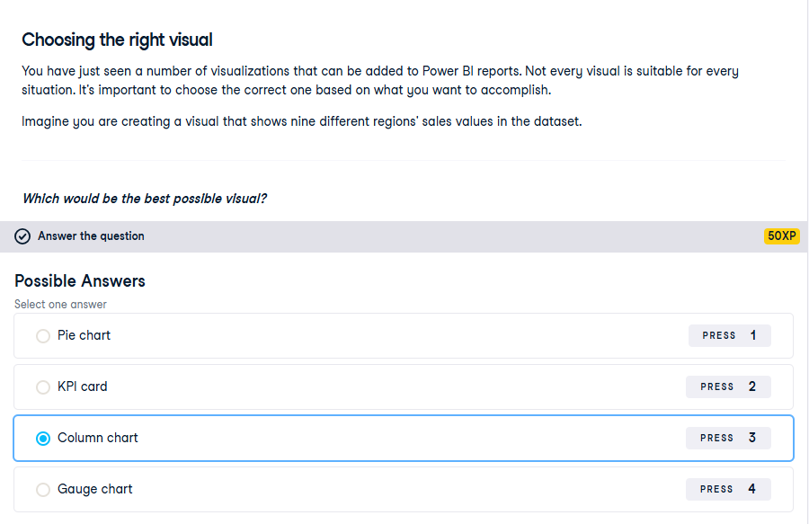

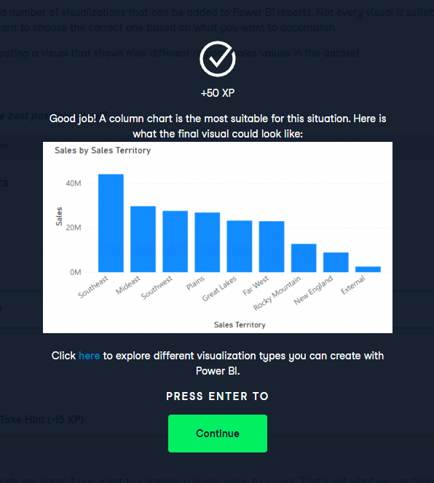

**Exercise 3.1**

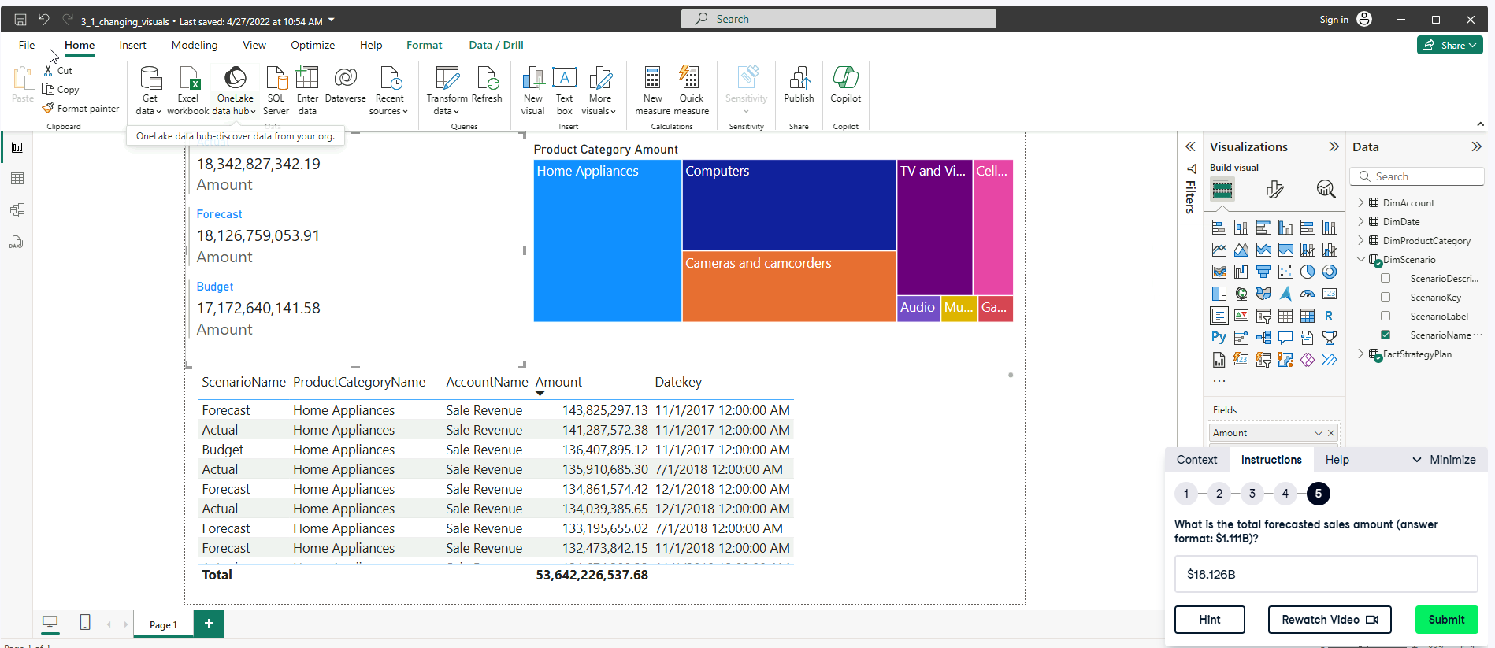

**Exercise 3.2**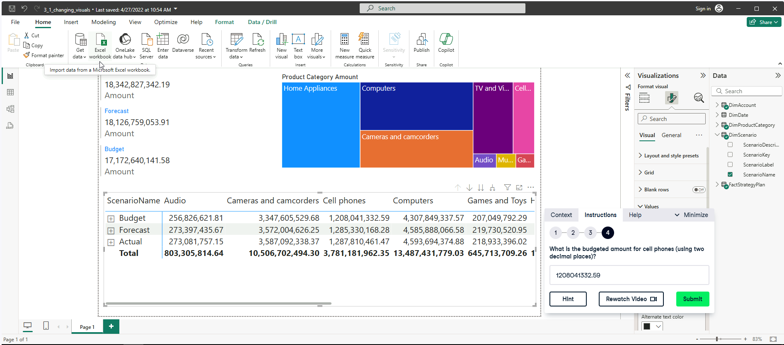

**Exercise 3.3**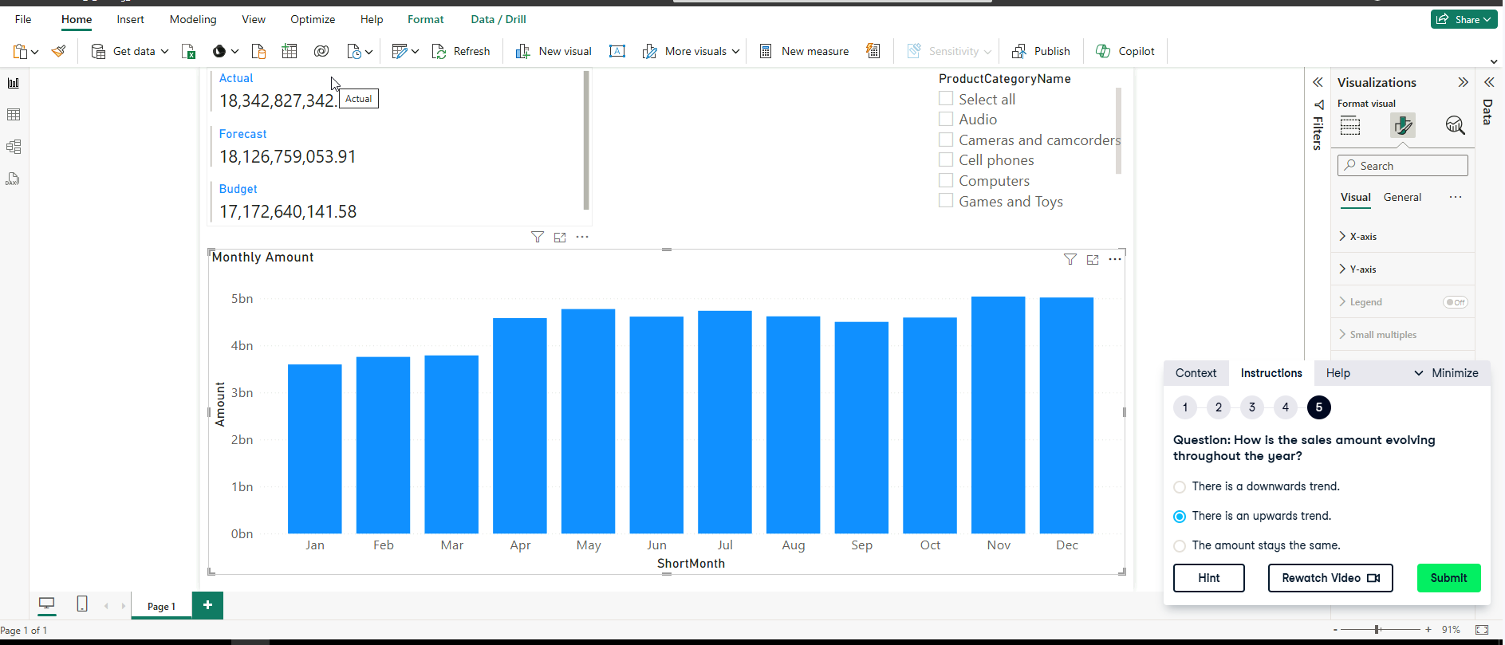

**Exercise 3.4**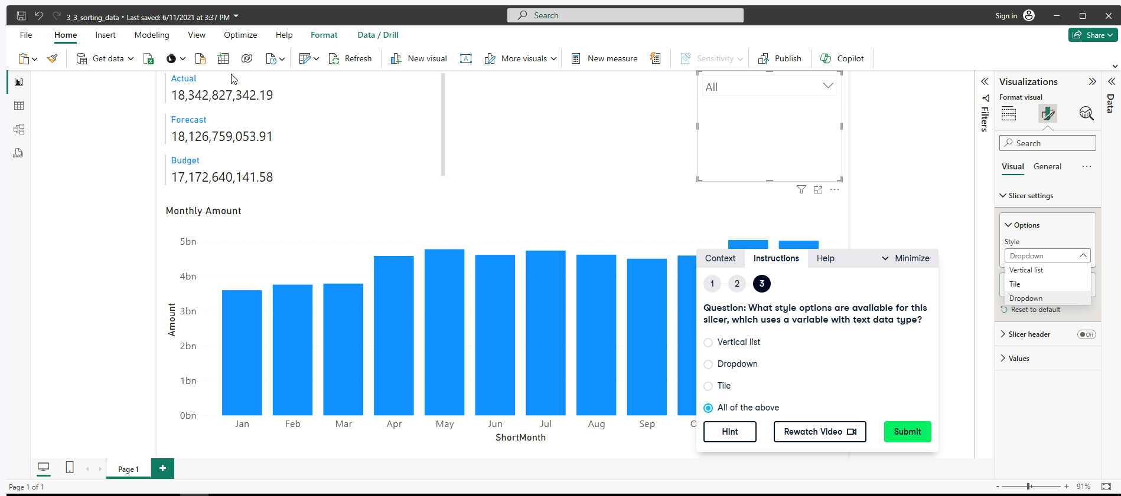

**Exercise 3.5**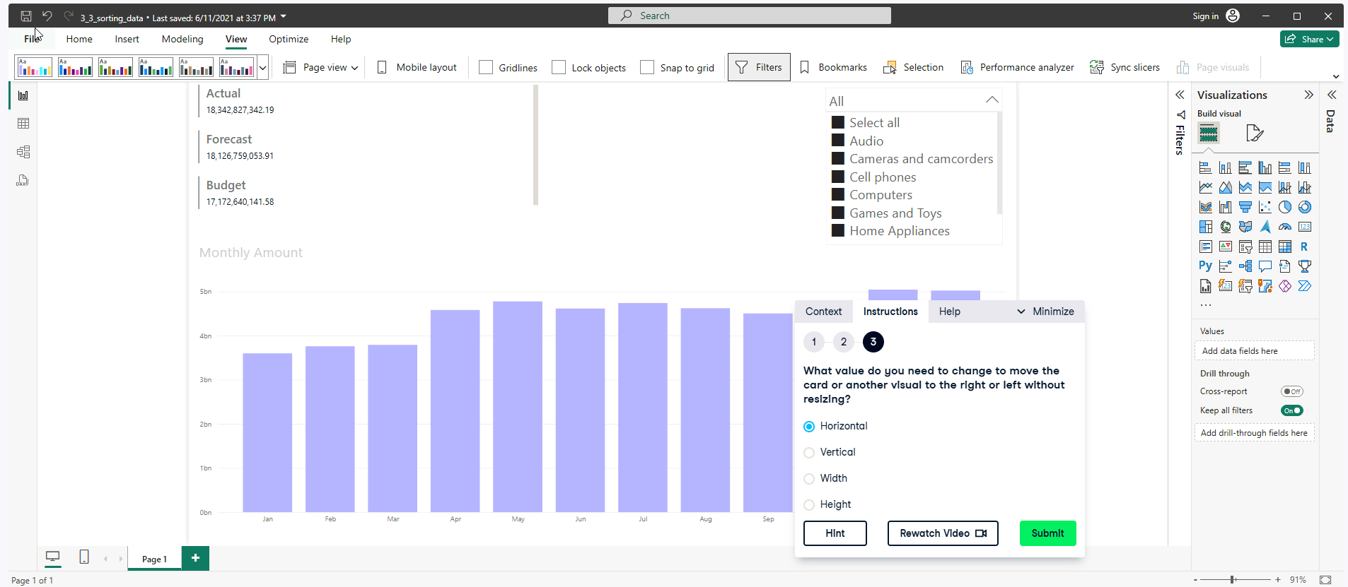

**Filtering** 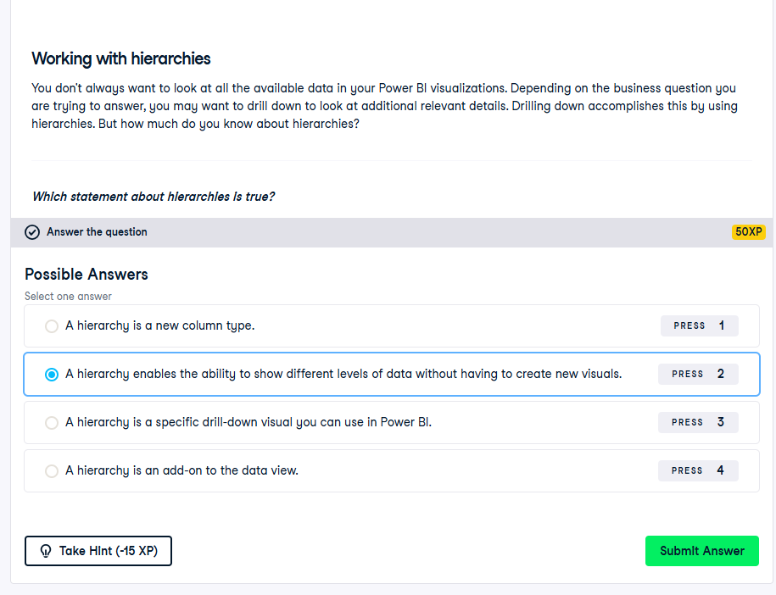

**Exercise 4.1**

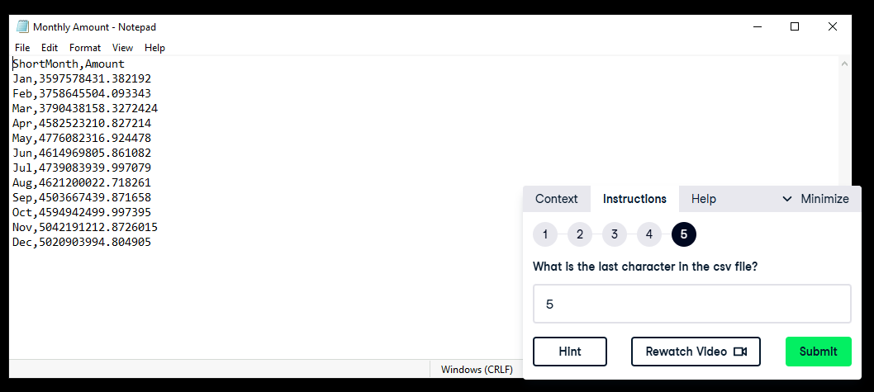

**Exercise 4.2**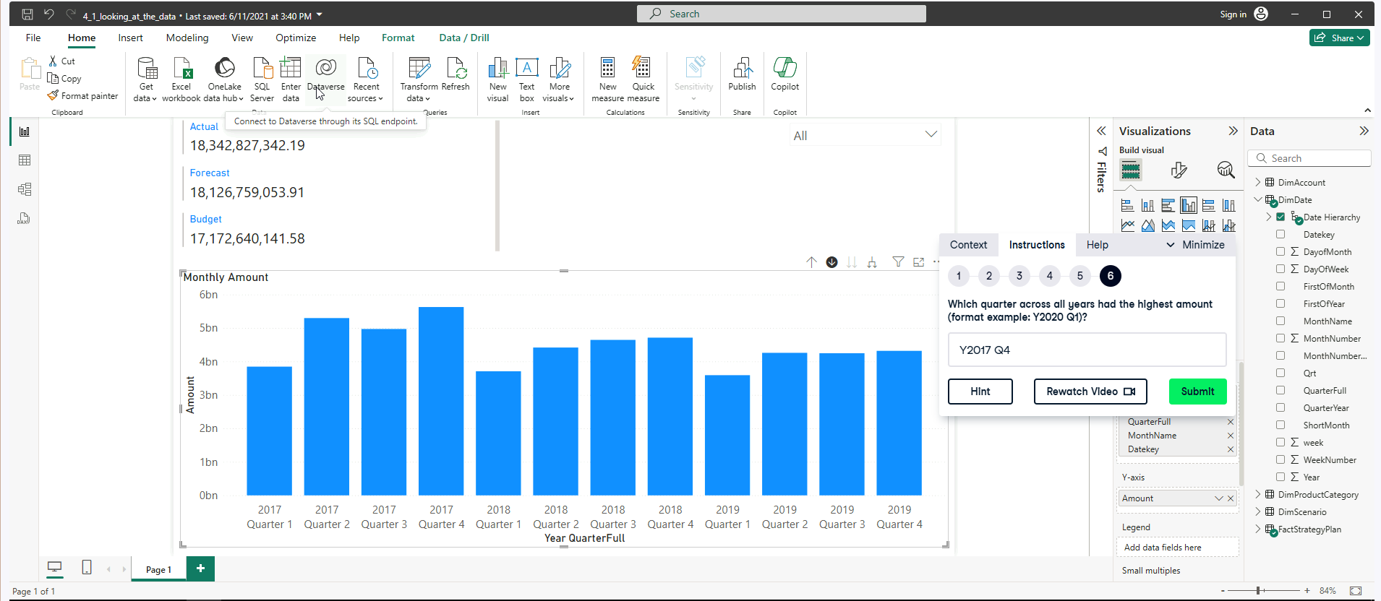

**Exercise 4.3**

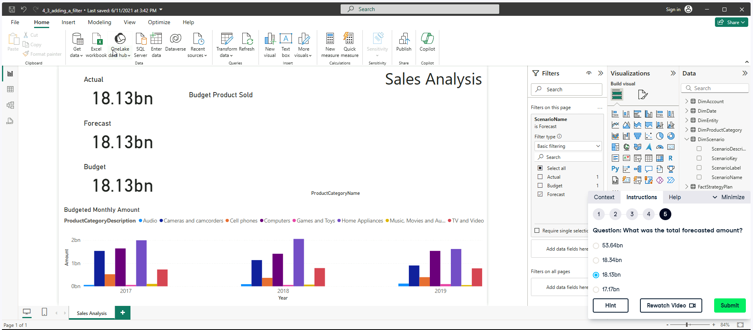

**Exercise 4.4**

**Try opening the 4.4 exercise**

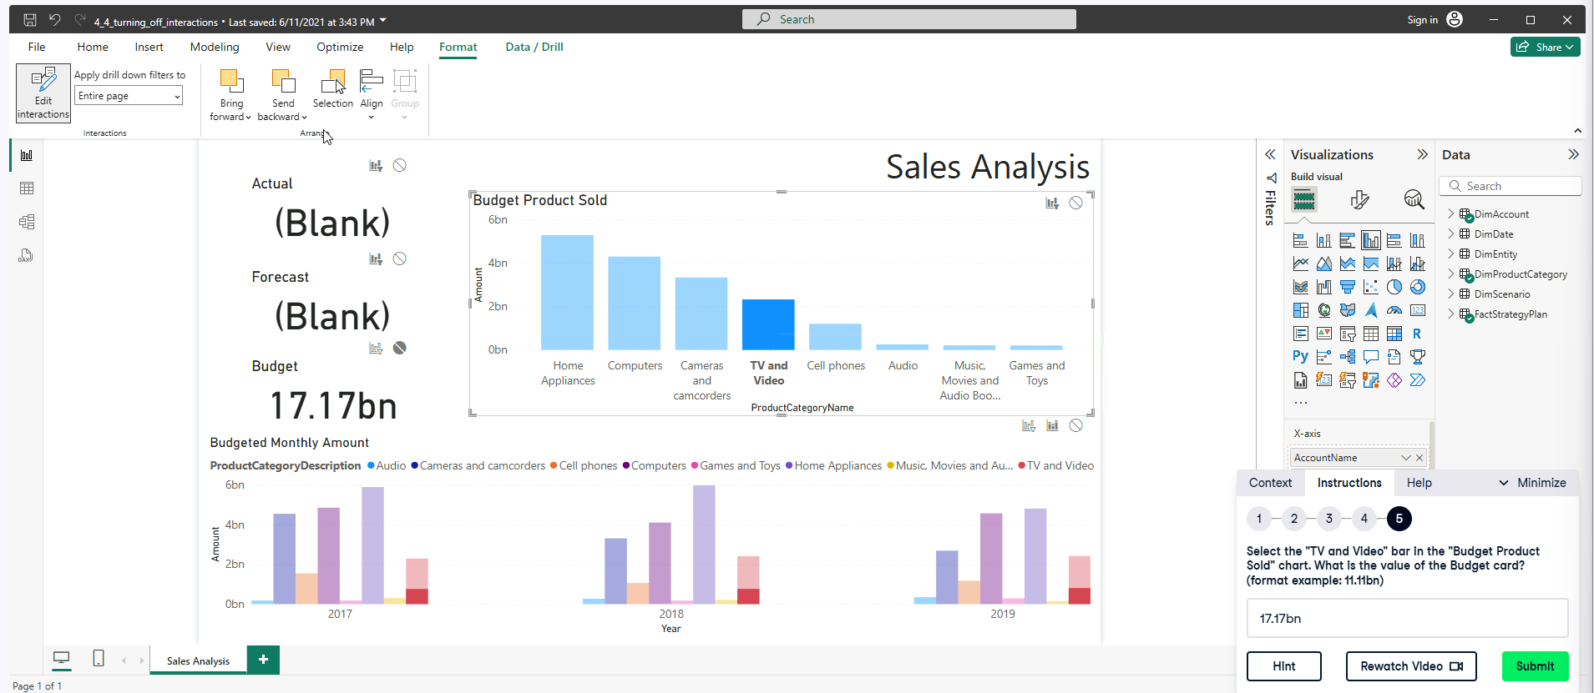

**Exercise 4.5**